

**W. P. CAREY SCHOOL OF BUSINESS HONOR CODE MASTER’S PROGRAMS**

We, the students of the W.P. Carey Master’s programs, are committed to maintaining the highest levels of honesty, integrity, and professional courtesy for ourselves and amongst our classmates. We believe that ethical behavior is not only the cornerstone of a good academic program, but of good business as well. As such, we are steadfast in our commitment to the following principles:

* Academic Integrity – We view the W.P. Carey Academic Integrity Policy as a living, breathing document, not just concepts on a page. As such, we are resolute in ensuring that we abide by the principles contained within, both in letter and in spirit. Furthermore, we will hold our classmates to the same high standards to which we hold ourselves.

* Consideration of Others – As W. P. Carey students, we believe that we should treat others as we wish to be treated. To this end, we will be considerate of classmates, professors, and recruiters in all aspects. Furthermore, we will constructively add to the collaborative environment by helping and encouraging others.
* Professionalism – As W. P. Carey students, we believe that the behaviors we practice today will become habit in the future. To that end, we are committed to act in a professional manner in all school settings, including classes, networking events, and interviews. We will be cognizant of the fact that we are representing the program and our classmates at all times.

Full Name (printed): __YUGANTIKA NOLASTNAME________________________________________

Signature_____ YUGANTIKA NOLASTNAME ______________________________ Date 5/5/20222

Full Name (printed): __ANURAG BHATTACHARJEE______________________________________________

Signature_____ ANURAG BHATTACHARJEE _____________________ Date __5/5/2022_______

Full Name (printed): _YASH JAIN_______________________________________________

Signature____YASH JAIN_________________________________________ Date _5/5/2022___

Full Name (printed): __JING HAO______________________________________________

Signature____JING HAO___________________________________ Date __5/5/2022________

Full Name (printed): ______DINESH KOONAMAKKAL__________________________________________

Signature___ DINESH KOONAMAKKAL ___________________________________ Date _5/5/2022____

Onsite MSBA Applied Project Report

Spring 2022

W.P. Carey, ASU

|  |  |
| --- | --- |
| Topic | ***Exploring interaction of autonomous vehicles with all objects around*** |
| Team | Team B-11 |
| Team Members | *Anurag Bhattacharjee, Jing Hao, Yash Jain, Dinesh Koonamakkal, Yugantika* |
| Client information (if applicable) | Capstone- WAYMO |

**CONTENTS**

* Project Background & Objective
* Overview of Dataset
* Project Execution
* Project Progress – Till Interim Presentation (Progress 1,2,3 & 4)
* Recall
* Progress 5 – Steps to Construct a Classification Model, Feature Engineering, Model Compilation & Evaluation
* Feature Engineering- Business Model
* Limitations
* Conclusion & Recommendations
* Key Takeaways
* References

**OBJECTIVE**

Autonomous vehicles and human-robot teams are two very forward-looking topics that have potential for positive impact by introducing sustainable methods of transportation.

Google launched its Waymo division to develop and market consumer-ready driverless vehicles around the globe. The objective of autonomous vehicles along with Waymo is to provide convenience, cost & safety to make them ubiquitous and indispensable.

Through this Project we investigated the open dataset by Waymo, called Perception & Motion Datasets, containing both camera images as well as point-cloud data generated by LIDAR

*Objective Interaction & Motion Analysis*

We specifically extracted and characterized interactions with all objects, or nearby, autonomous vehicles, and identified appropriate car-live object interactions and attempted to provide insights of poor human interactions

**OVERVIEW OF DATASET**

The Waymo Open Dataset is comprised of **high-resolution sensor data collected by autonomous vehicles operated by the Waymo Driver in a wide variety of conditions**.

It is composed of two datasets **Perception Dataset** and **Motion Dataset**

**Perception Data Set**

* The perception dataset contains independently generated labels for lidar and camera data, not simply projections.
* **The Perception dataset is what we are using for our project**
* In the Perception dataset, Waymo provides **3D bounding box labels** in LIDAR data. The following object classes have 3D labels：

**Vehicles**

**Pedestrians**

**Cyclists**

**Signs**

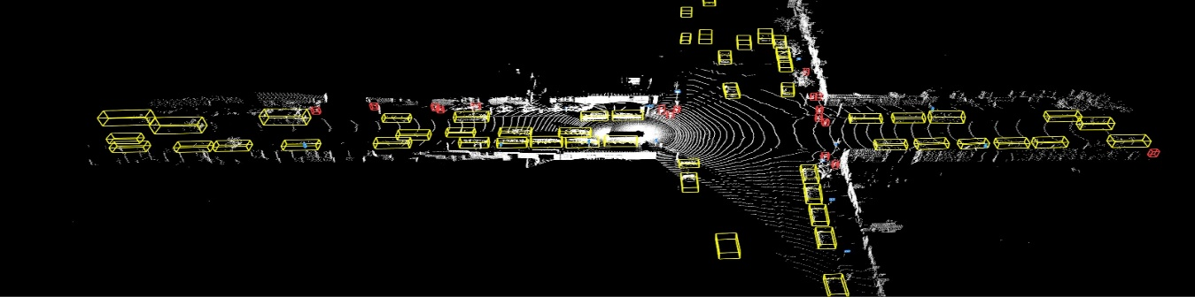

For building Image Classifier in the last phase, we also explored the possibility of deep diving into Berkely Deep Drive Data set to amp up the sample size of negative interactions & build an image classifier model

[](https://deepdrive.berkeley.edu/)

**PROJECT EXECUTION**

We have processed the TensorFlow records and captured data collected from 1,000 driving segments done by its autonomous vehicles on roads.

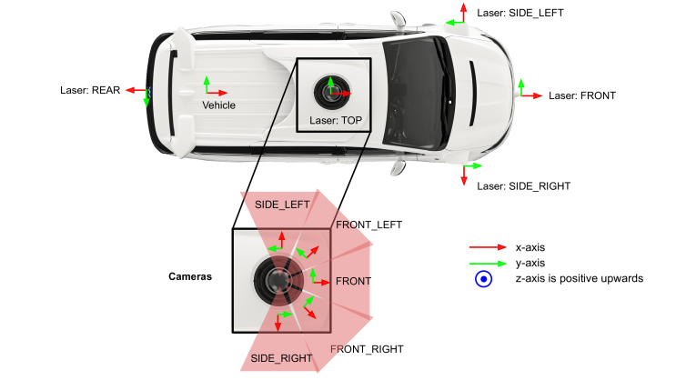

The segments include data collected from five of Waymo’s five standard cameras that face front and to the sides, providing a 360-degree view captured in high resolution and imaging data. Objects, including vehicles, pedestrians, cyclists and signage is all labeled and offering a range of different driving conditions, including at night, during rain, at dusk and more.

**Image Extraction**

**Video Extraction**

Initially we were capturing images one by one, we have extracted about 4000 images, including about 800 images with pedestrians.

But later, performed experimentation over the code to capture segments representing 20 seconds of continuous driving. We have extracted 308 videos with pedestrians.

**Building Image Classifier**

Based on the minimal quantity of negative interactions obtained via Waymo dataset we explored Berkeley Deep Drive Data Set as well & finally created an image classifier using CNN model & Resnet 50 architectures

**PROJECT PROGRESS – TILL INTERIM PRESENTATION (PROGRESS 1,2 & 3)**

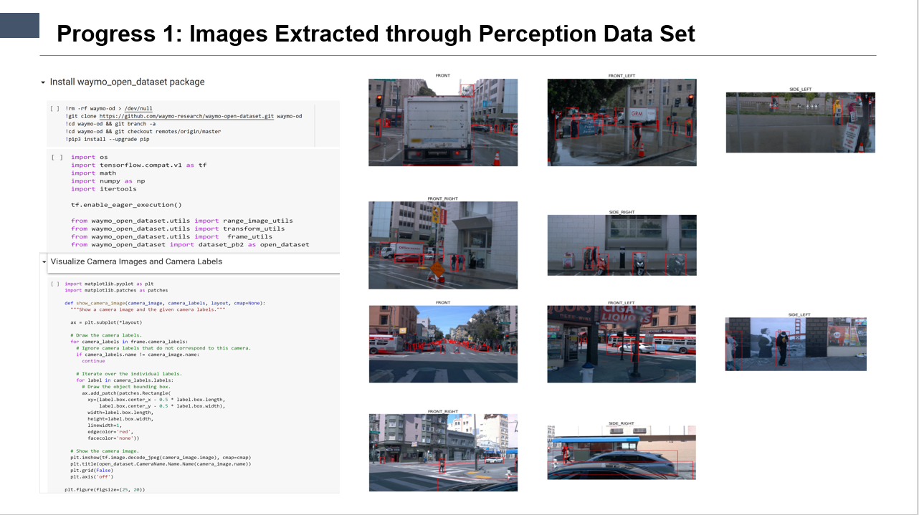

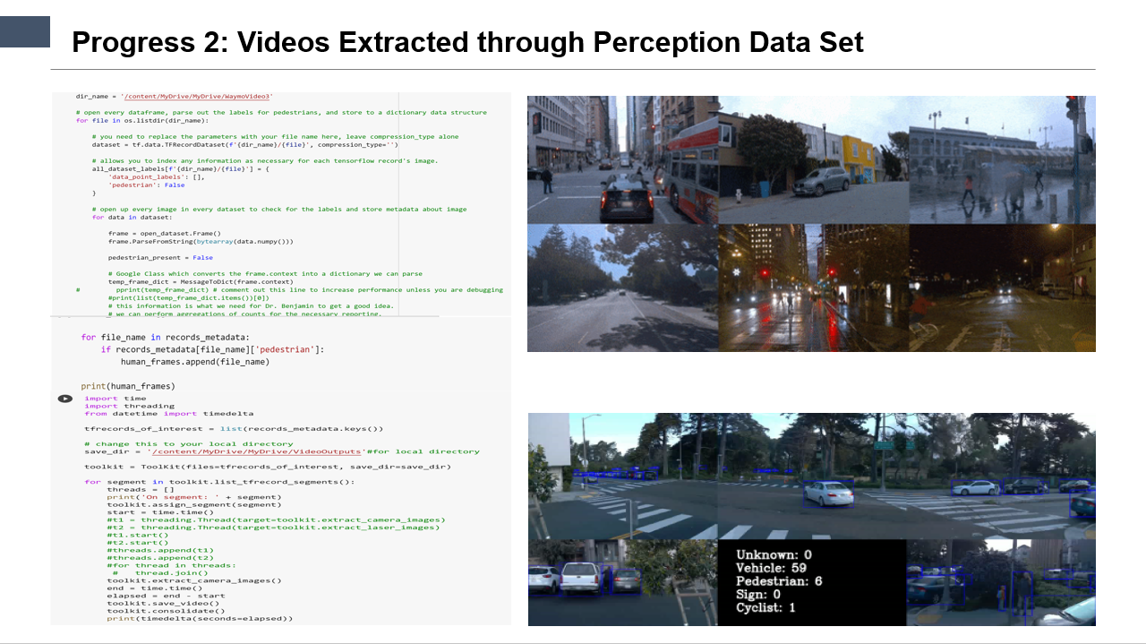

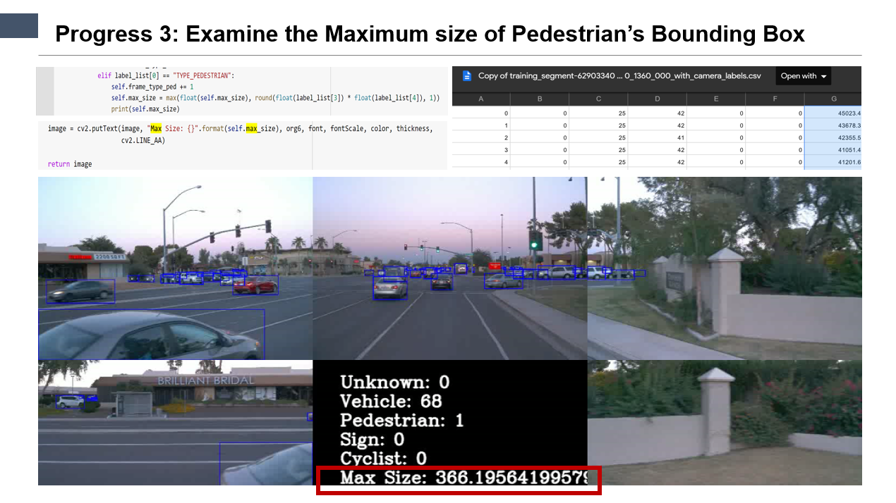

**PROJECT PROGRESS – TILL INTERIM PRESENTATION (PROGRESS 4)**

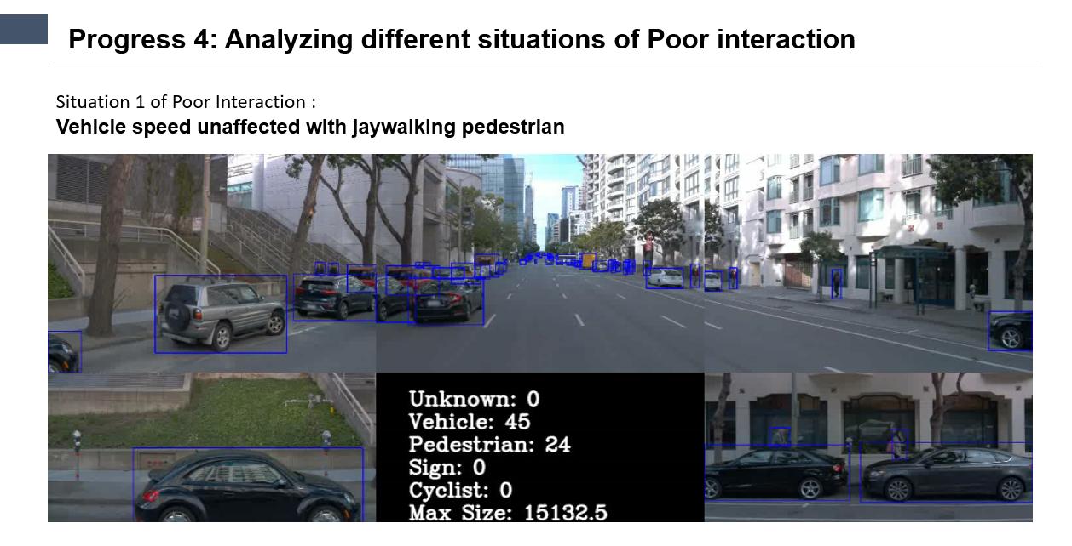

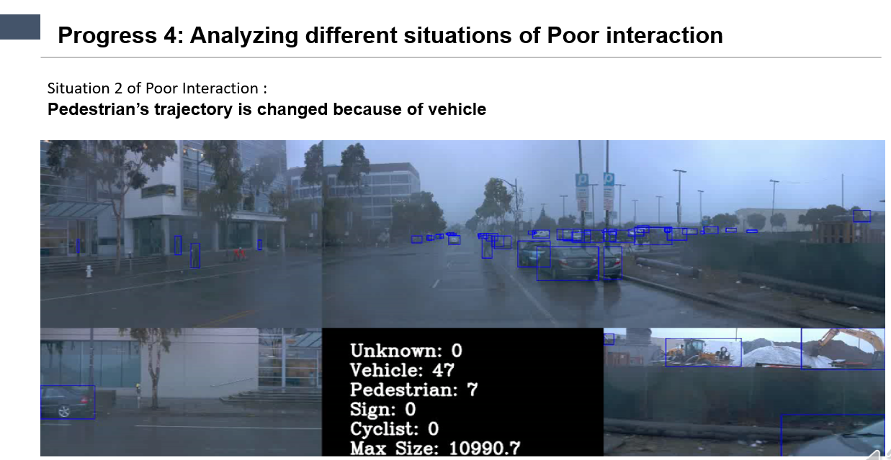

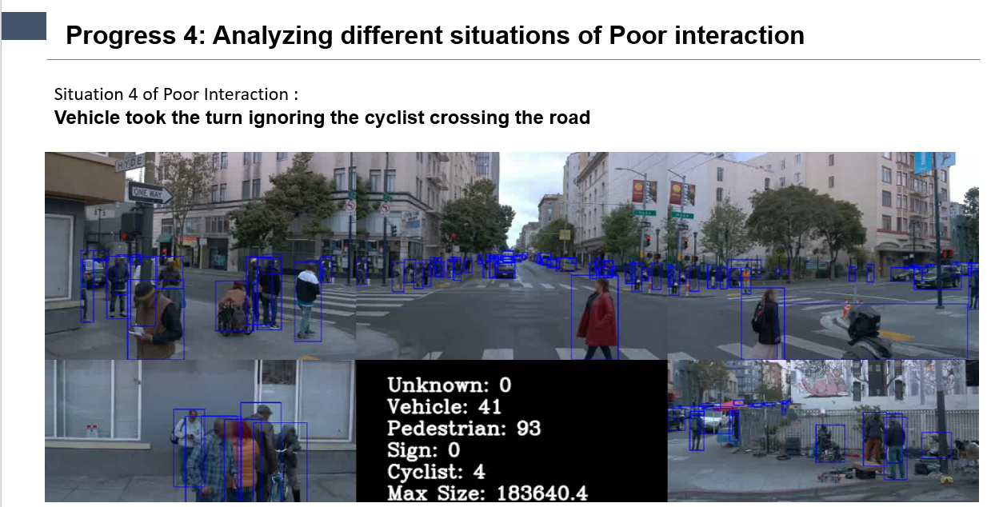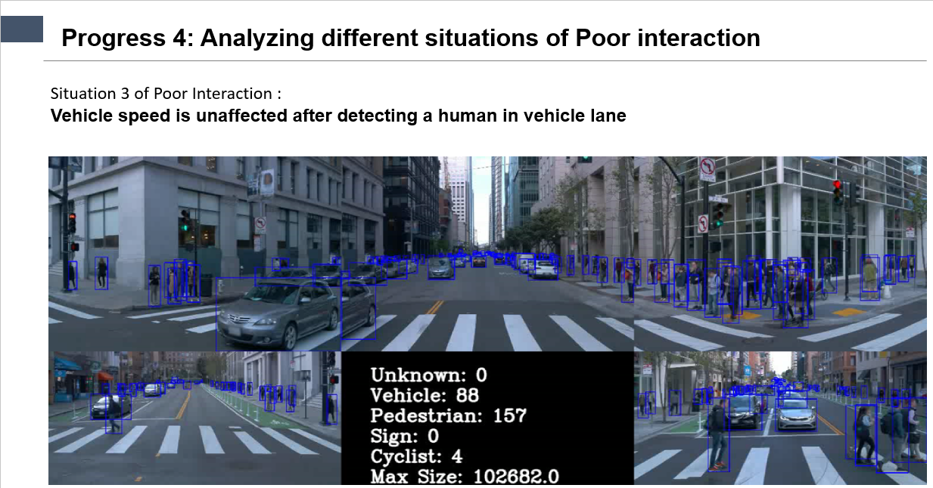

**Recall**

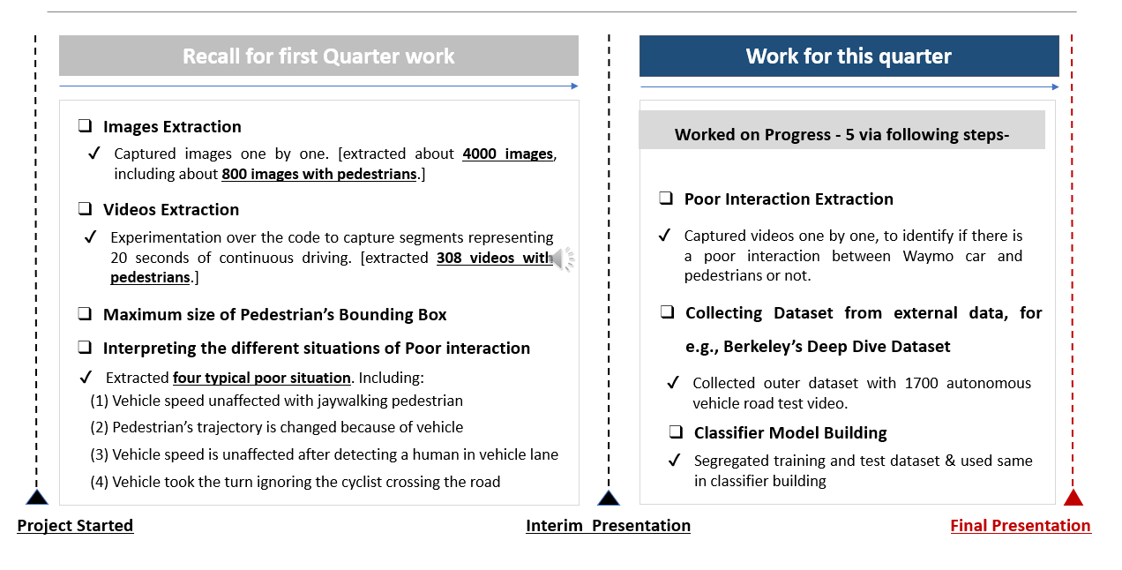

**Progress 5 - Steps to Construct a Classification Model**

**QUARTER 1**



1. Extracted 798 videos from Waymo Perception Dataset

2. Extracted 308 videos with pedestrians

3. Extracted 7 videos with poor pedestrian interactions.

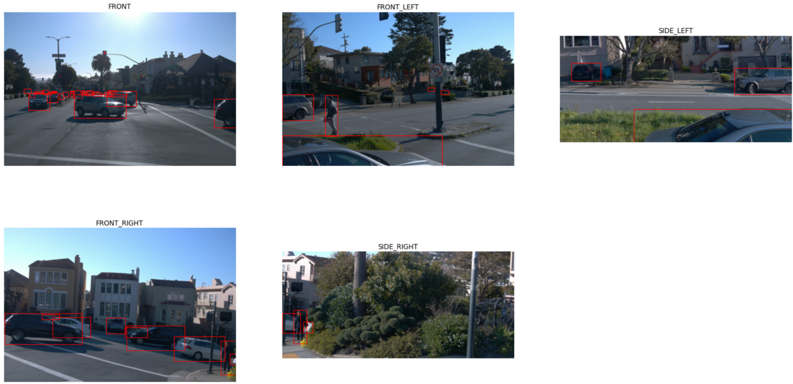

**QUARTER 2**



**Split**

**Data**

**Split the extracted pedestrian interaction videos into train and test folders** each having positive, negative, and neutral interactions samples.

**Extract frames** from each video and **label them** according to **different classes** based on interaction (0:  if no interaction, 1 if positive/neutral interaction, 2 if negative interaction).

**Extract Frame**

After preprocessing we have around **5552 frames of labelled training data** and **3173 frames of labelled testing data** for our model. 

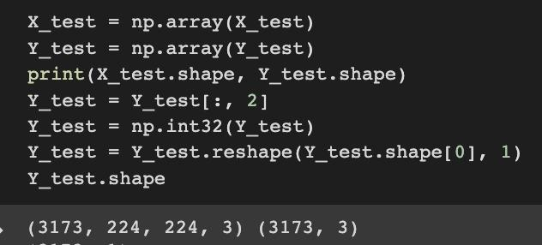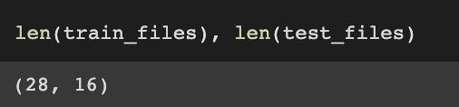

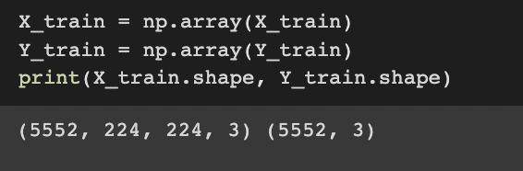

**Progress 5 – Feature Engineering**

* We have utilized **ResNet-50** (pre-trained on ImageNet) to extract features from image frames
* Used incremental learning to train a classifier on top of the extracted features
* When performing *deep learning feature extraction*, we treat the pre-trained network as an arbitrary feature extractor, allowing the input image to propagate forward, stopping at pre-specified layer, and taking the *outputs* of that layer as our features
* Doing so, we utilize the robust, discriminative features learned by the CNN.

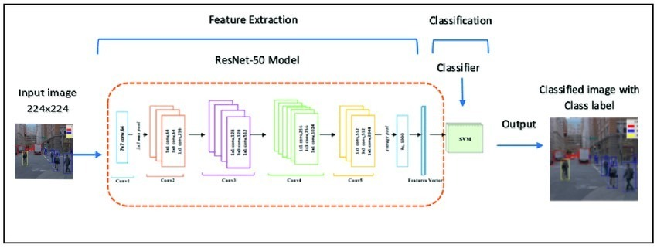

*Schematic Diagram of Model*

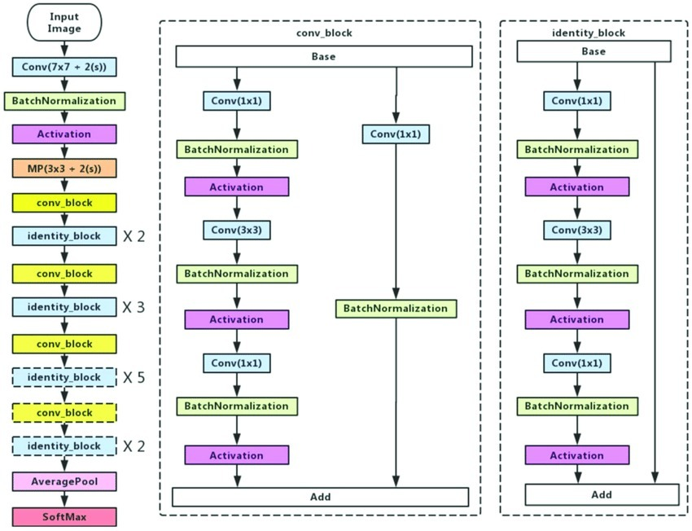

*Resnet50 Architecture*

**Progress 5 – Model Compilation**

* While importing the ResNet50 class, we mention include_top=False. This ensures that we can add our own custom input and output layers according to our data
* Finally, we mention layer.trainable= False in the pretrained model. This ensures that the model does not learn the weights again, saving us a lot of time and space complexity
* We have imported a pre-trained model; we will also add a fully connected and output layer *where actual learning can take place*
* We used the SoftMax activation function, and we have 3 output neurons corresponding to the 3 classes in our data(0: if no interaction, 1 if positive/neutral interaction, 2 if negative interaction)

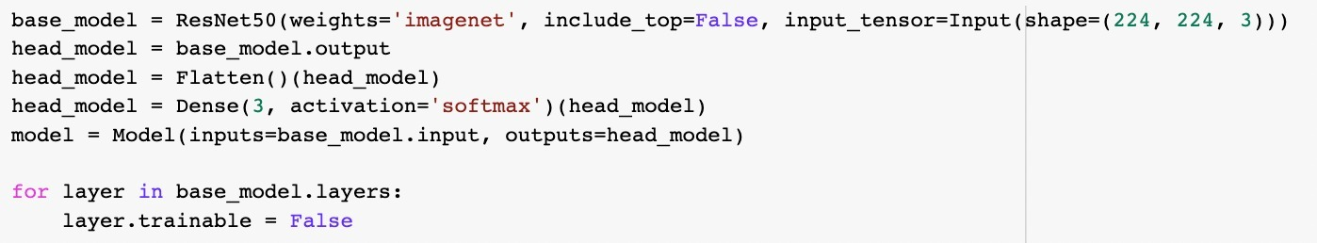

Once the model is ready, we simply compile it and train it over 3 epochs

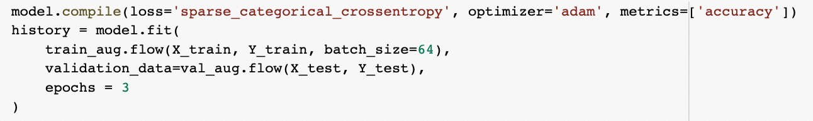

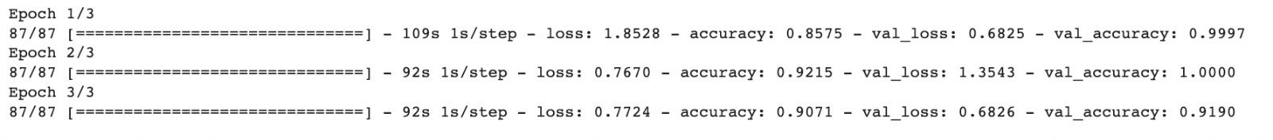

**Progress 5 – Model Evaluation**

* We used the matplotlib library to plot the train and validation accuracy with respect to each epoch
* We also analyzed the training and validation loss plots at each epoch

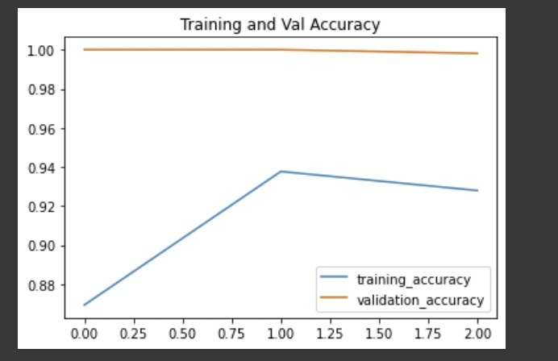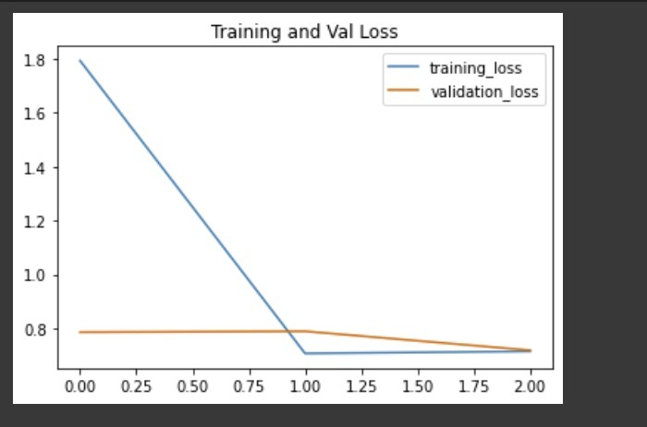

Over the course of 3 epochs, the training as well as validation accuracy increases

Over the course of 3 epochs, the training as well as validation loss decreases

**Feature Engineering- Business Model**

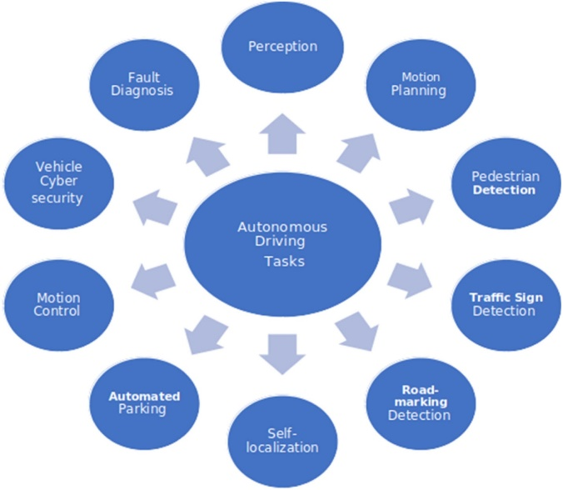

From a business perspective, there are certain things for autonomous driving vehicle which we need to consider for detection, distinguishing, and categorizing items & actions and implementing an apt retort for driving atmosphere

Also, it requires to have the option to distinguish and react to different vehicles (all through its movement way), people on foot, bicyclists, creatures, and another item

**Limitation**

1. When images being captured, the adjacent frames on occasions capture the same pedestrians and count them as multiple instances, occurred when pedestrian was in motion already, reaches a point & covered by both the cameras subsequently i.e. overlap in the range covered by adjacent cameras, and leading to incorrect count displayed for the human in front of the Waymo Car.

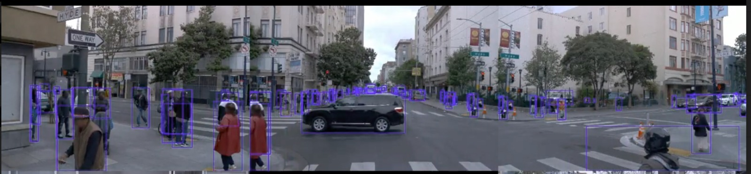

1. The labels do not provide any data with respect to the velocity of the Waymo Car, this was a limitation while trying to identify poor interactions
2. The dataset shared by Waymo is an imbalanced data set & it is available to all, so there is a chance that it has been sanitized before it has been provided public access
3. We used 2-D perception Data Set for our research, but later Waymo released 3-D data set which might have resulted into better results in terms of visualization, if we could have used the same initially. The new released 3-D data set also has more information for e.g., new interactions scenario, addition of latitude & longitudinal dimensions & positions of the object, etc.

**Conclusion & Recommendations**

* Analyzing the segments that depict unique pedestrian-car interaction we observe that car sometimes tend to show poor interaction behavior which can be fatal in practical scenarios
* Irrespective of the detection being based on LiDAR or stereo cameras, the proximity of cars with the pedestrians can be detected by the size of the bounding boxes based on the dimensions of the localized objects
* Vehicle can estimate the distance from the other objects and control its speed accordingly, but it seems its unable to sense whether the traffic rules are being followed like in the situation where the person has parked outside of the parking lane
* This highlights the urgent need of the Waymo's vehicle to comply with road rules and react properly to potential conflict partners
* Based on the high number of positive interactions we observed in the Waymo Dataset, it is affirmative that Waymo is consistently improving its capabilities, monitoring & upgrading its algorithms to minimize the poor/negative interactions

**Key Takeaways!!**

Working on highly unstructured data set

Dealing with ambiguity

Image Classifier Functions while using Resnet-50

Applying Business Model while using Technical deep learning model

Developing a model to track & classify the interaction of other road users with the Waymo Car

Use domain knowledge to extract features to identify interactions from the video samples and improve model performance



**References**

* [**https://deepdrive.berkeley.edu/project/interaction-and-communication-between-pedestrians-and-autonomous-vehicles**](https://deepdrive.berkeley.edu/project/interaction-and-communication-between-pedestrians-and-autonomous-vehicles)
* [**https://github.com/bdd100k/bdd100k**](https://github.com/bdd100k/bdd100k)
* [**https://www.therobotreport.com/confused-waymo-robotaxi-shows-challenges-of-scaling-avs/**](https://www.therobotreport.com/confused-waymo-robotaxi-shows-challenges-of-scaling-avs/)
* [**https://www.sciencedirect.com/science/article/pii/S2666827021000827**](https://www.sciencedirect.com/science/article/pii/S2666827021000827)

Thank You!!